October 2024 - MONTHLY BOARD MEETING MINUTES Downtown Residents' Council, Inc.
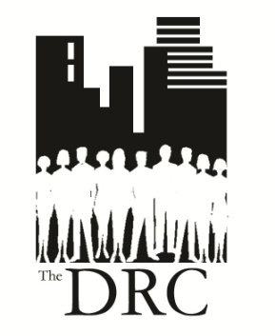
Date: October 7, 2024 @ 6:00 pm

Place: First Financial Innovation Center, 4th & Vine Streets

Members Unable to Attend: Seth Harmon, Tracey Johnson, Kurt
Grossman and Tim Nolan

President Jackie Bryson called the meeting to order at 6:00PM.

Approval of September 2024 Board Meeting Minutes:
Tricia Lynn motioned to approve the minutes, Sue Byrom seconded, and all voted in favor.

Approval of Treasurer’s Report: (report provided prior to meeting)
Teri Boland motioned to approve the report, Mary Heimert seconded, and all voted in favor.

Reports of Committees and Projects:
Finance:
Tricia Lynn started the process for requesting next year’s funds from the Neighborhood Support Program (NSP). She confirmed the committee members working with her to request the funds (Kurt Grossman, Esther Wing, Jackie Bryson and Teri Boland). The committee will meet prior to the start of the November 11th Board meeting at 5PM at First Financial to review funding suggestions and make selections. Organizations selected to receive funds will be presented at the January 2025 member meeting.

Information & Technology:
Tricia continues working on the domain transfer.

Social:
Mary has Willow Run arranged for the October social. Vintage on Race and Voodoo Brewing are interested in hosting socials in 2025. Jackie reported the new Mercantile Apartments on 4th street want to invite the DRC for a tour. John Faherty from the Mercantile Library plans to host a Library tour in January 2025.

Speakers:
Jackie reported 3CDC will provide an overview of upper OTR developments and the Findlay rec center at the October member meeting. Anna Barchick, 3CDC, plans to attend the November Board meeting requesting a letter of support for the upper OTR developments.

Community Budget Request:
Chase Mosijowsky submitted funding for two projects. 1) Development of a Downtown Neighborhood Plan. 2) Removal of a large blue column and concrete pad at the entrance to the Path to the Taft on 700 E Pete Rose Way.

New Business Items for Discussion/Action/Assigning or Deferring:
Mary is working through logistics with Prime Cincinnati for the annual Holiday party. The Board agreed the cost per guest of $40.

Old Business:
Tricia will have non-profit donation suggestion forms available at the October member meeting.

Sue spoke about the liquor license request from Something to Wine About on W. 4th Street. Based on current issues with venues on 4th street Chase Mosijowsky motioned to object the request, Lisa Sprague seconded, and all voted in favor. Jackie will follow-up with a meeting request to 3CDC to discuss current issues.

Jackie asked the Board to look at the second pass of the member survey and give her feedback. Tonight’s discussion was postponed.

Other topics postponed include: 1) VP to complete term until April 2025, 2) 2025 Executive Committee members and 3) Transition/migration to new domain.

Announcements:
Esther Wing asked if Zoom meetings could be provided from First Financial Innovation Center. Currently, we are unable to provide this from the Center. Esther also noted she will post 2025 Board member opportunities to the DRC Facebook page.

Adjournment:
The meeting adjourned at 7:14PM.

Next meeting: November 11, 2024, 6:00 pm., First Financial Innovation Center

